Maintaining the Ruffed Grouse

By Dan and Silene Snyder
Grouseparkwaterfowl.com
GROUSEPARK@YAHOO.COM

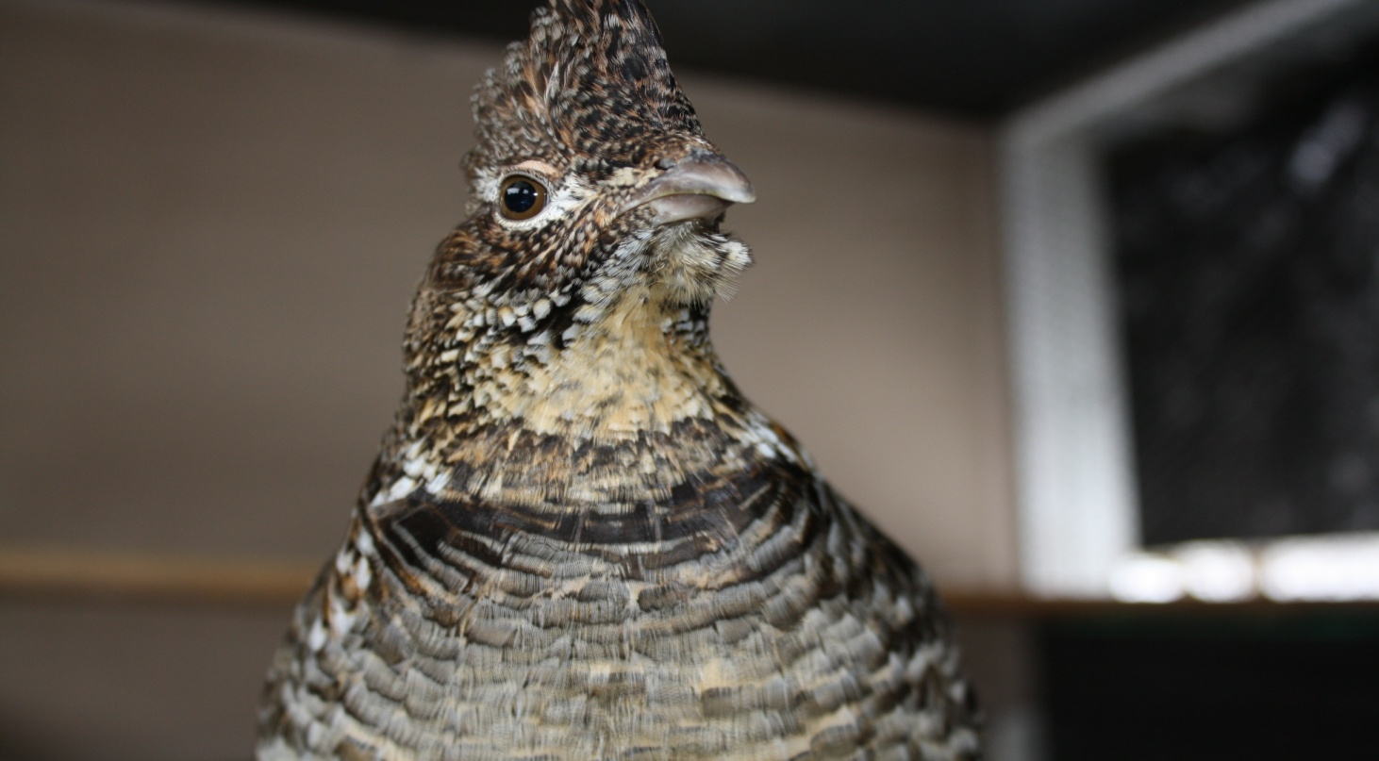

In the Fall
Once you receive a pair of Ruffed grouse, you should put them in separate pens side-by-side so they can clearly see each other as shown in photo below:

xxx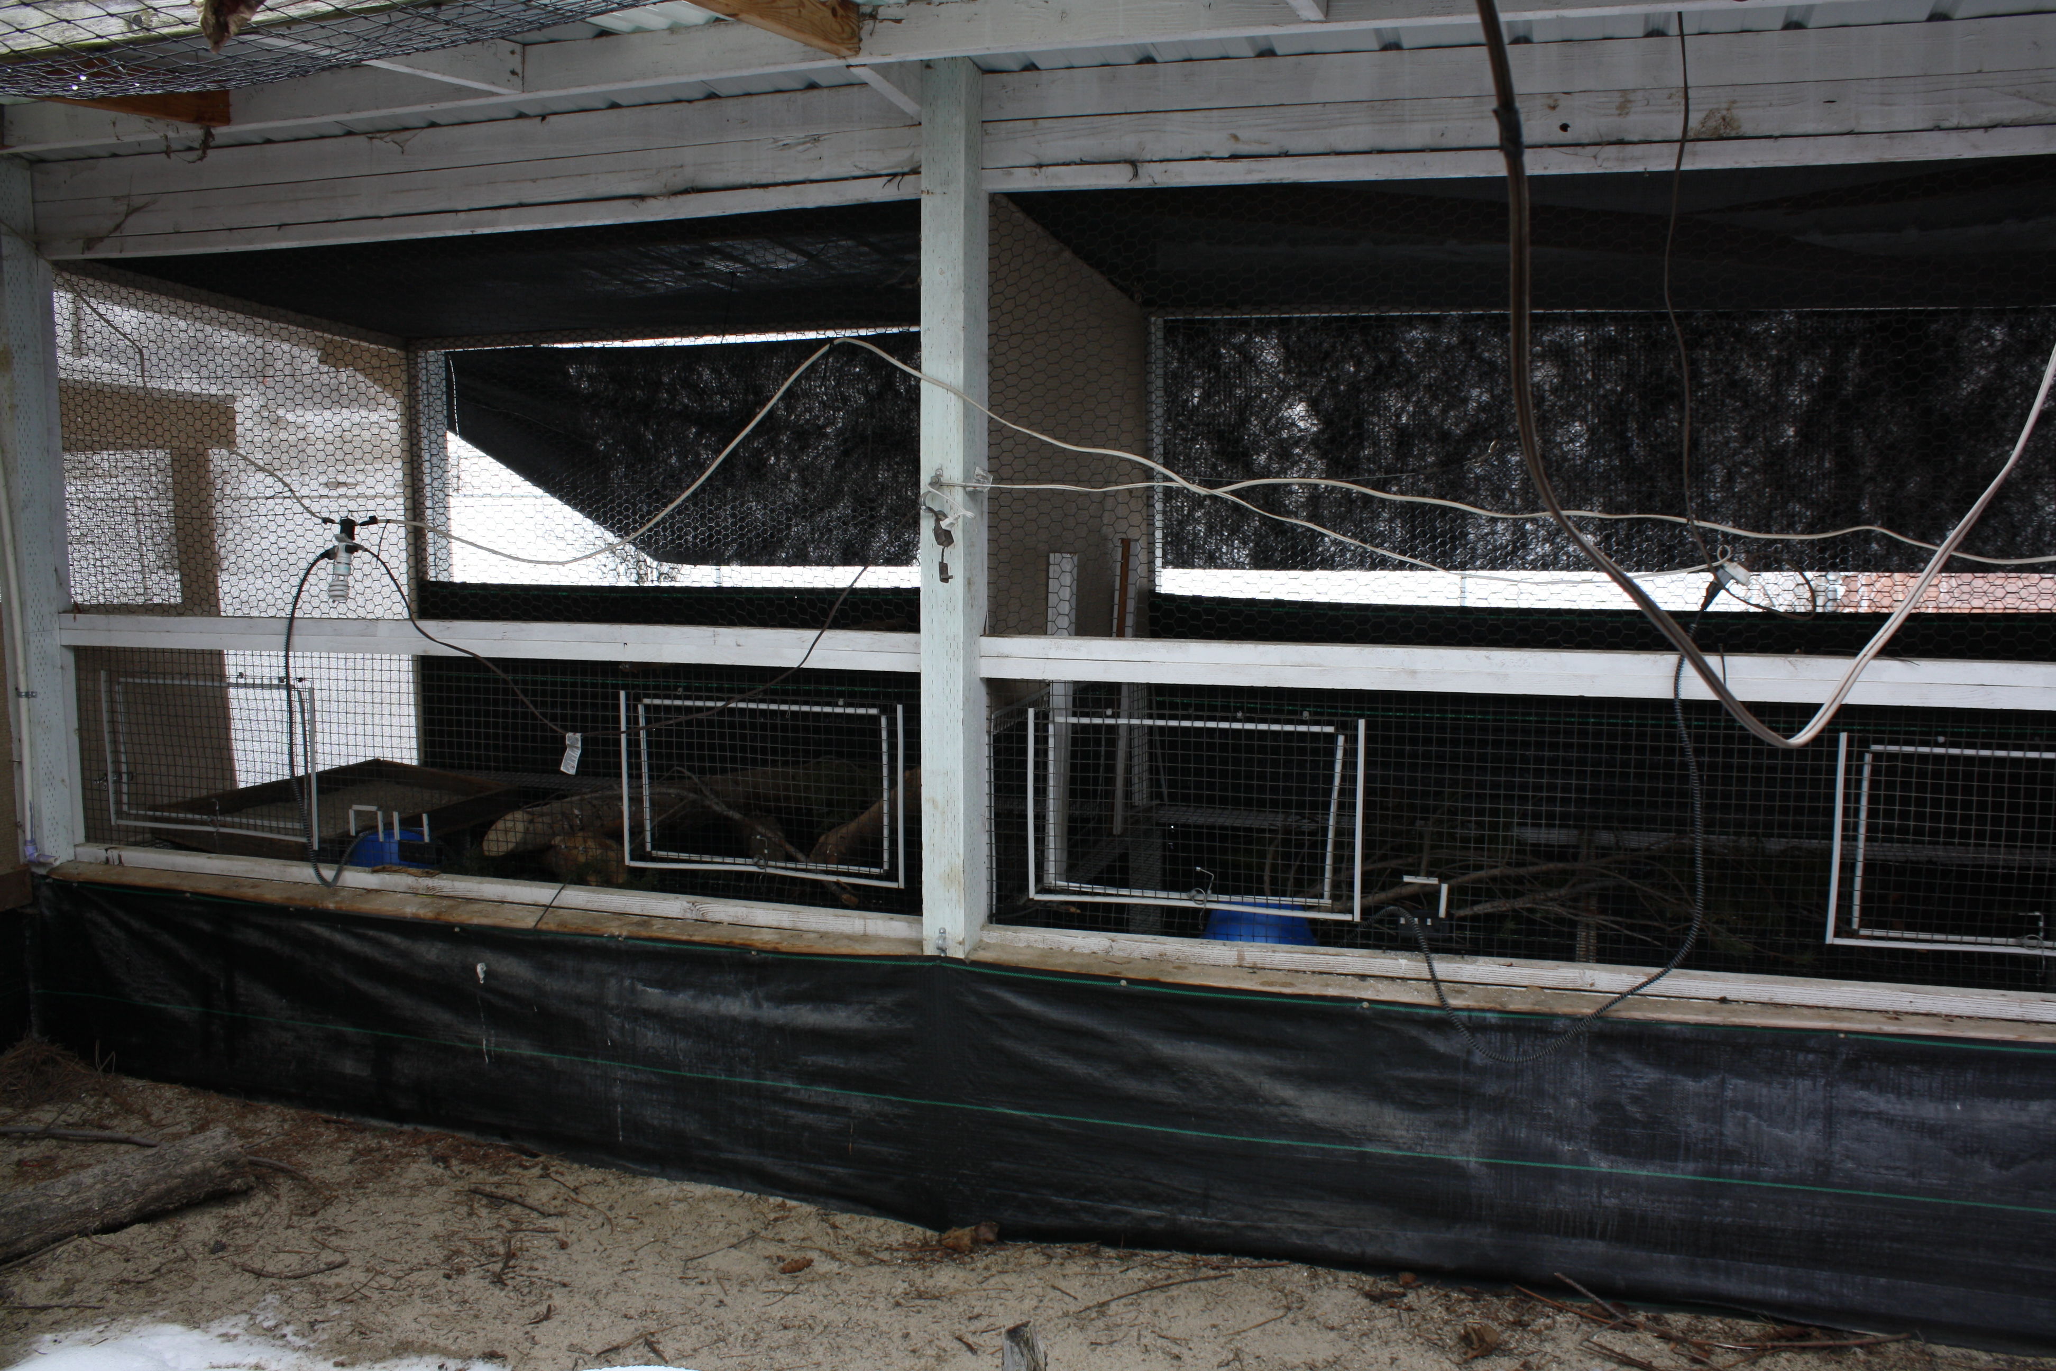
Photo of pen with doors.

This will allow the male to gain his confidence throughout the winter going into Spring and will allow the pair not to chase and harass each other. A good size pen is 5’wide, 8’long, 6’tall, with a soft top ceiling to help prevent damage to their heads. As we are building cages we install shade cloth about 5”-6” below the metal roofing. When something spooks them, they will bounce off the ceiling instead of breaking their necks on the metal roofing or hard wire top. Each bird will have a wooden sand box made in our shop 18”long, 16”wide, and 4’ tall. The reason for wood is when you get a very bad rain storm you want the water to pass through the box. Installation of perches is as follows: we cut lodge pole pine trees that are 6’-7’ tall with a diameter of around 1 ½” and then proceed to clean all the branches off. You want a clean perch. We install one very low in the pen around 16” off of the wire and another about 12” down from the soft top ceiling. They seem to prefer to roost up as high as they can at night. A side benefit is that Great Horned owls are less likely to see them and mess with them at night.
It is also highly recommended that you would install an electric fence around the perimeter of your fence line as it will deter dogs and cats and most wild varmints. As for drinking water, we add one shot glass full of apple cider vinegar per one gallon of water year round. In fact in our region when it get above 85* degrees, we add 2 shot glasses per gallon of water to help prevent a problem we encounter here called sour crop. All feeders are placed over a food catch pan which is simply a 10”x10”X1½” box with ½” X ½” welded wire on top to catch the spilled feed, which can be put into a 5-gallon bucket. We typically only put enough feed for 1 day as we don’t want feed sitting in the open damp air any longer than necessary as it can cause fungal issues. We mix the Vionate minerals into the feed. We use 1 cup of Vionate per 5 gallons of feed. We do this by pouring the feed between two 5-gallon buckets until it is evenly mixed.
As you can see below in the two photos, we have a 1/16” cable with a pulley on the roof to allow us to open and close the doors without having to open pen doors:
Door Closed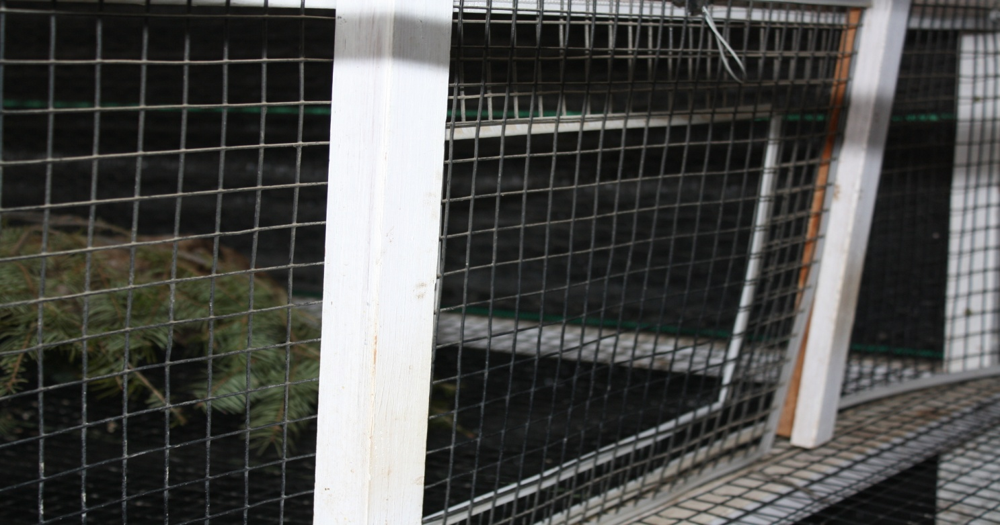

Door Open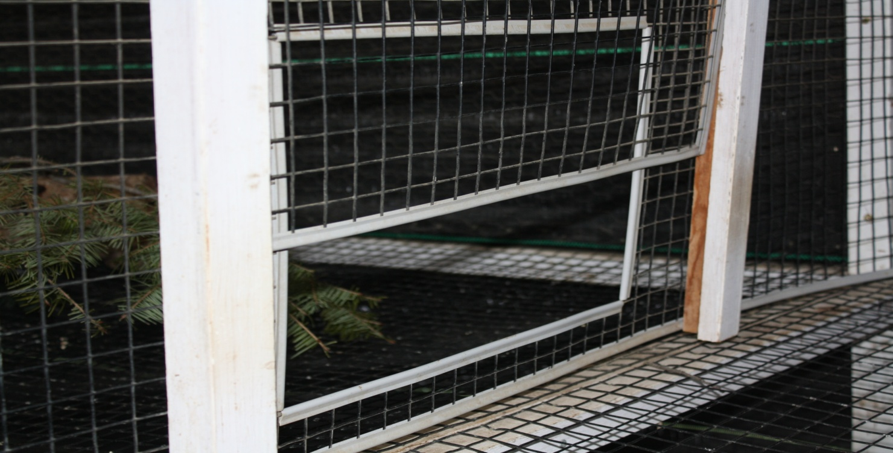

Feed and Water:
We feed Mazuri Game Bird Maintenance, 40lb, tag # 5649 from September 1st until around March 1st. As it is an extruded round pellet, our waste is almost zero. It helps with proper digestion and to produce good droppings. We then switch over to Mazuri Breeder, 40lb, tag # 5639 for the summer. We put 1 shot glass full of apple cider vinegar per 1 gallon of water. This helps prevent multiple fungal issues. We bleach water bowls daily in summer time and about every 3 days in winter here in Idaho. We also use heated pet bowls for every bird during the freezing times of year. We offer #1 size chick grit all year round. Grouse grit more than people realize and it is essential to proper digestion. Also, we include chopped-up cranberries daily for the birds. They really enjoy them and look forward to treats every day. It really makes a difference in their personality and health for their lives. The cranberries have a lot of Vitamin C.
Here are a few of the medicines we use at Grouse Park:
Nystatin Oral Suspension | Good for fungal issues
Ivermectin Sheep Drench | Good for worms
Fish Zole | Good for black head disease
Neo Med 325 | Good for Colibacillosis enteritis /Coccidiosis
Fast track Liquid Dispersible | We use during and for 3 days after any medicines given
Vionate Mineral Powder | We put on feed starting in December for our breeder flock

We hope this offers answers to some of your basic questions.
Kind Regards,
Dan, Silene, and Tristan Snyder
Contact Information:
Dan Snyder
P.O. Box 802
Council, Idaho 83612
Office 208-253-4694
Cell 208-566-3005
grousepark@yahoo.com
www.grouseparkwaterfowl.com

